Part I

1. Host a static website on Blob Storage: build and deploy a static Hello World website to Azure Storage. 2. Verify that the default web page has the Hello World! page.

3. Provide the steps and results.

In the visual studio code we install **extensions** Azure Storage

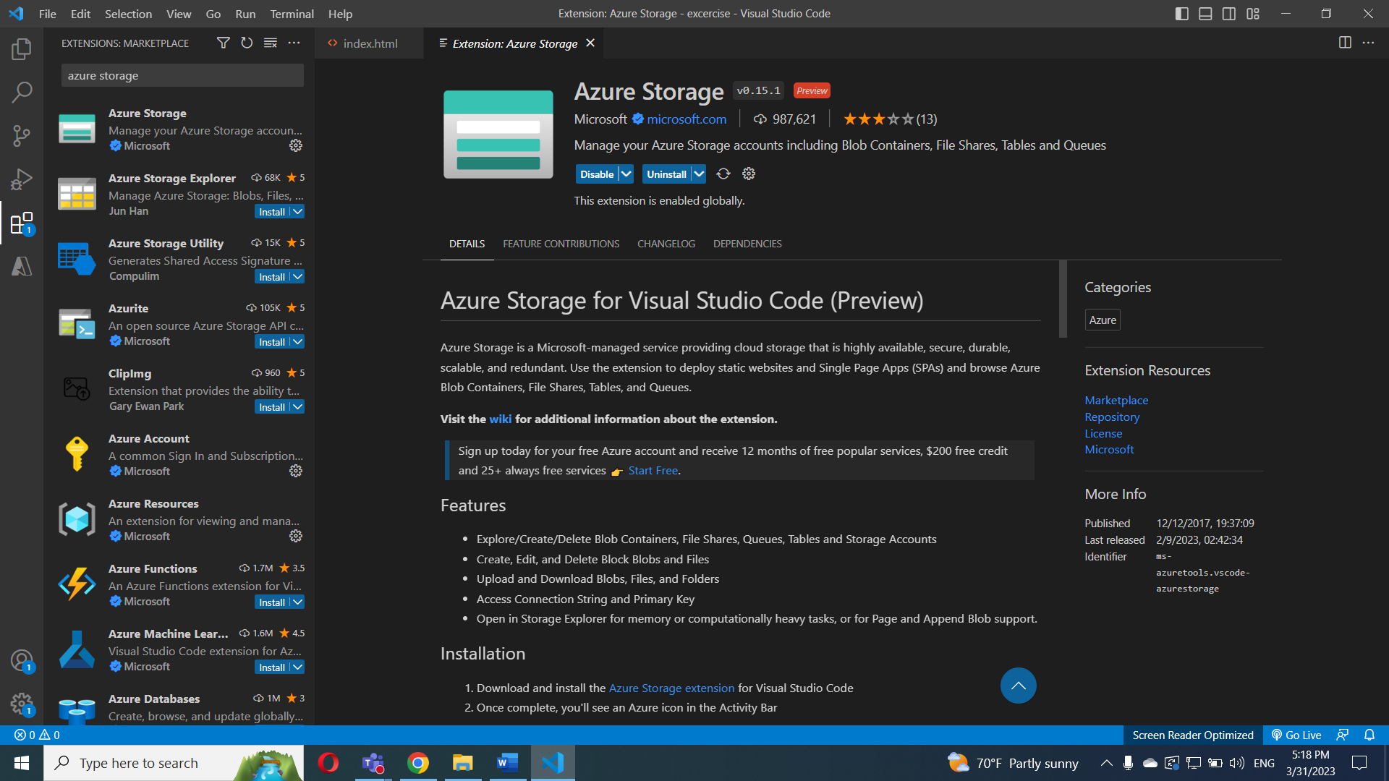

In the Azure in the storage account, I select static website.

At the first I enabled and write the name of the html doc

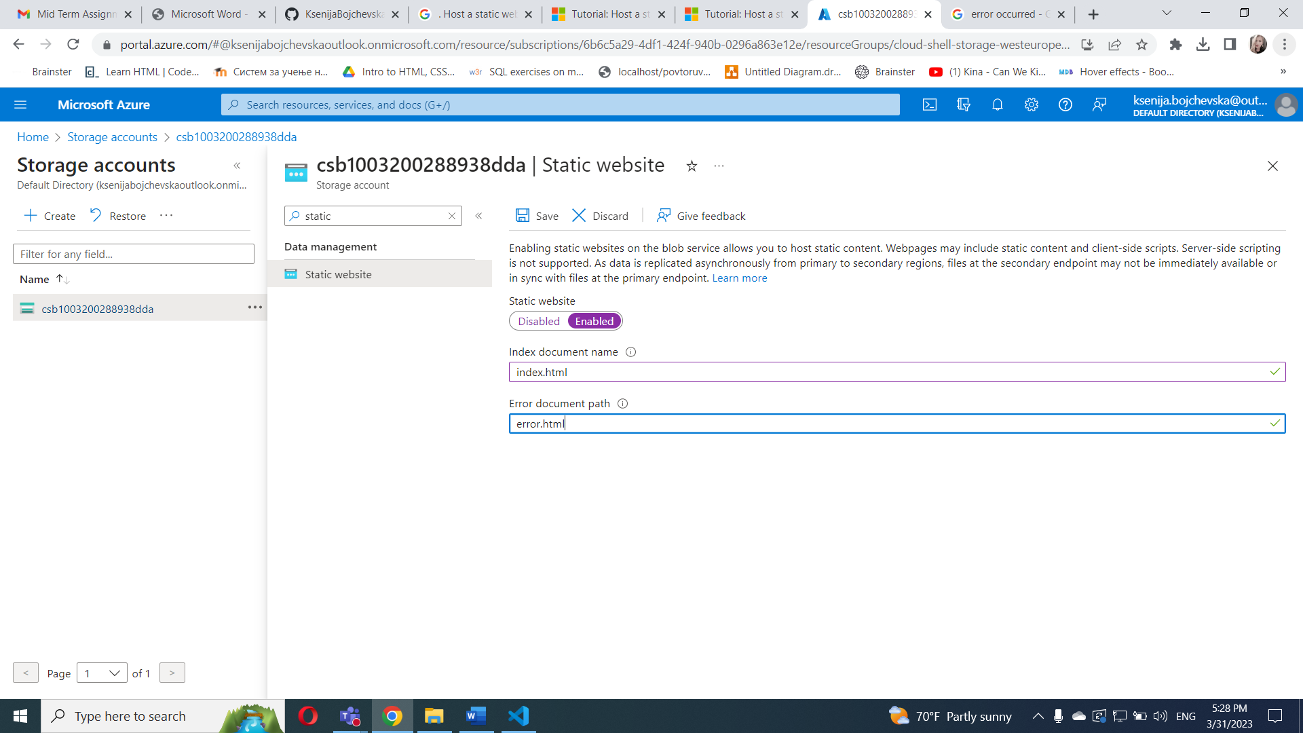

And after setting click save.

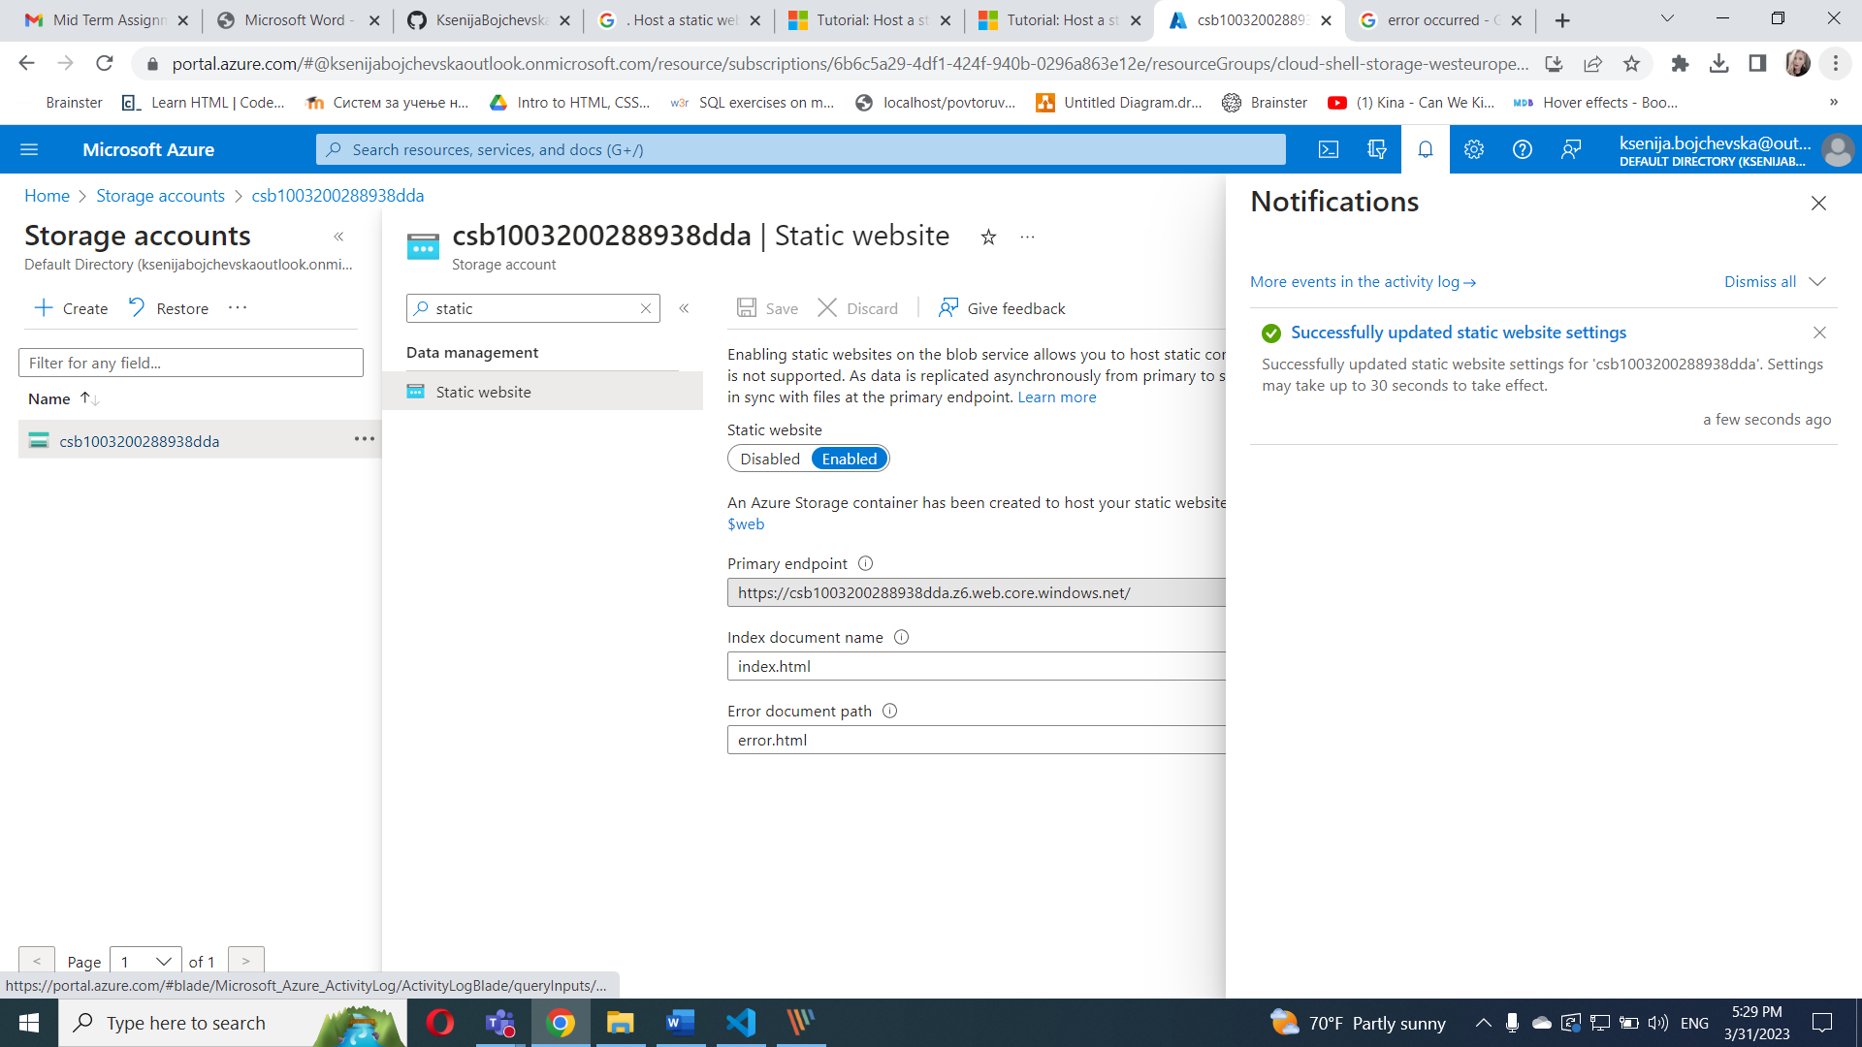

I created index.html and error.html doc with hello world in the index.html doc and error in the error.html doc

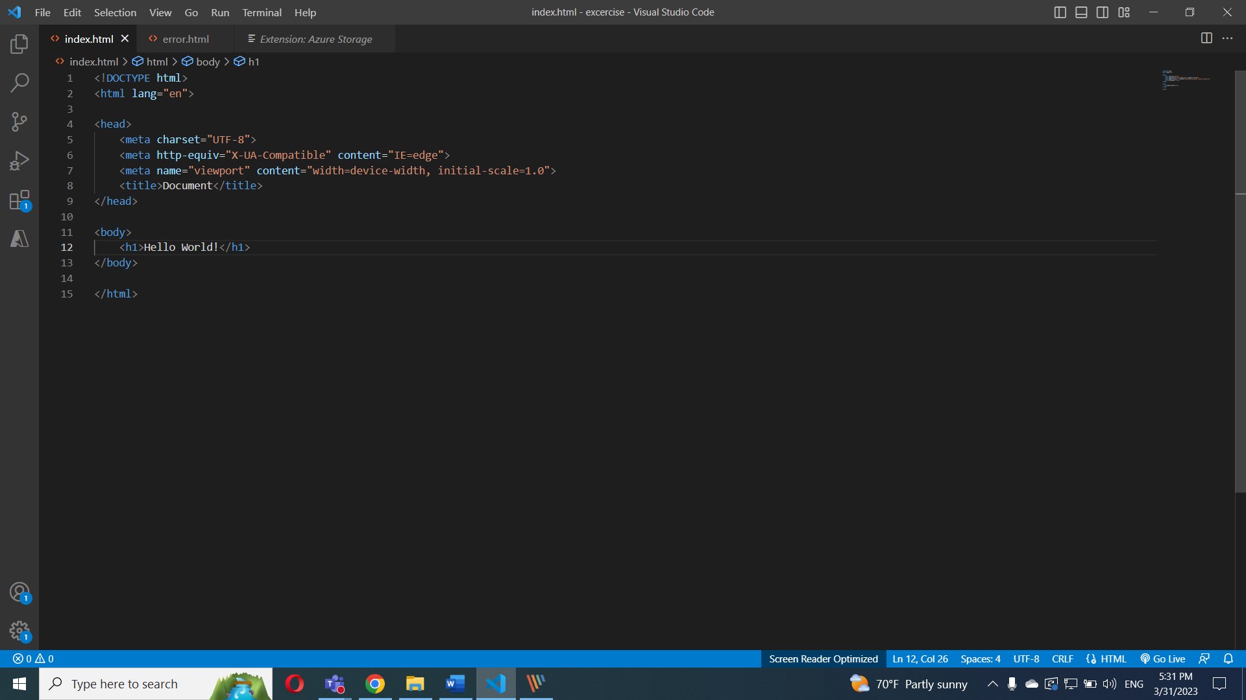

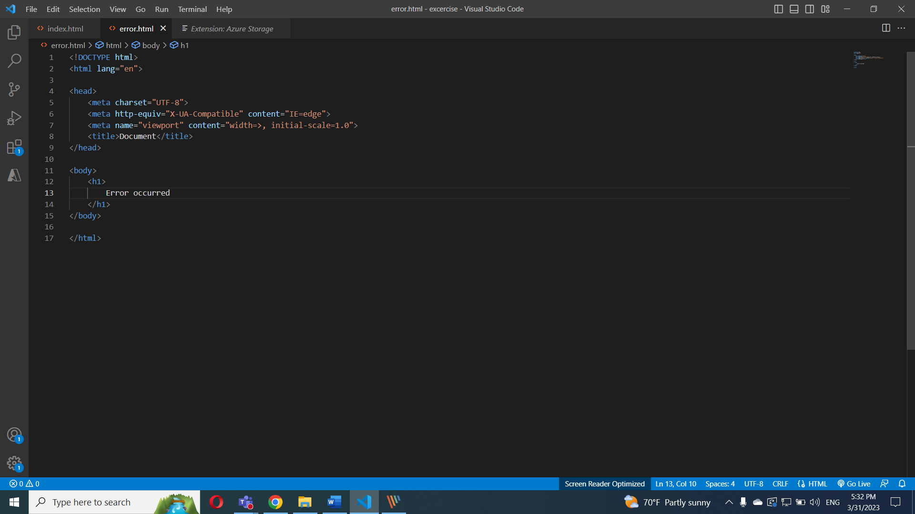

In the **Explorer**  panel, I select **Deploy to Static Website, and login in Azure**

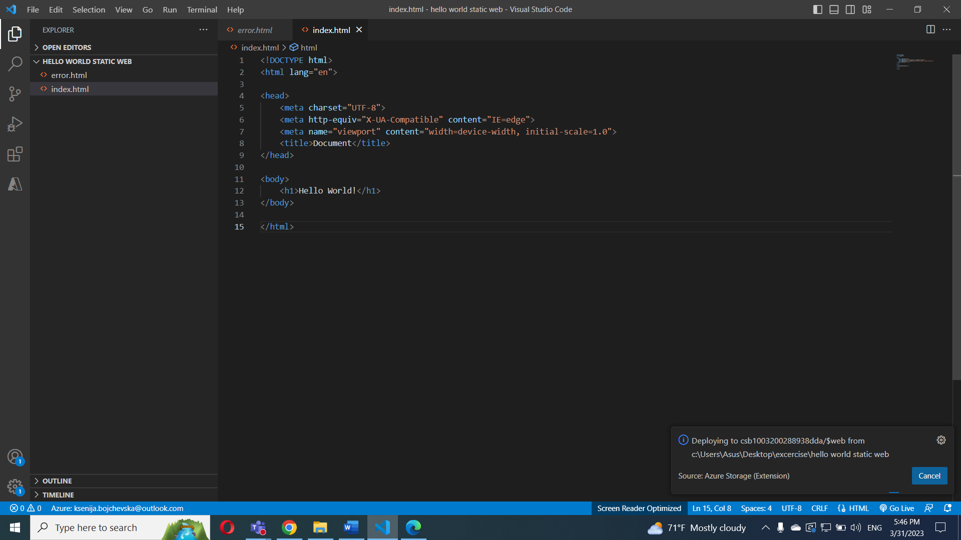

And the web is

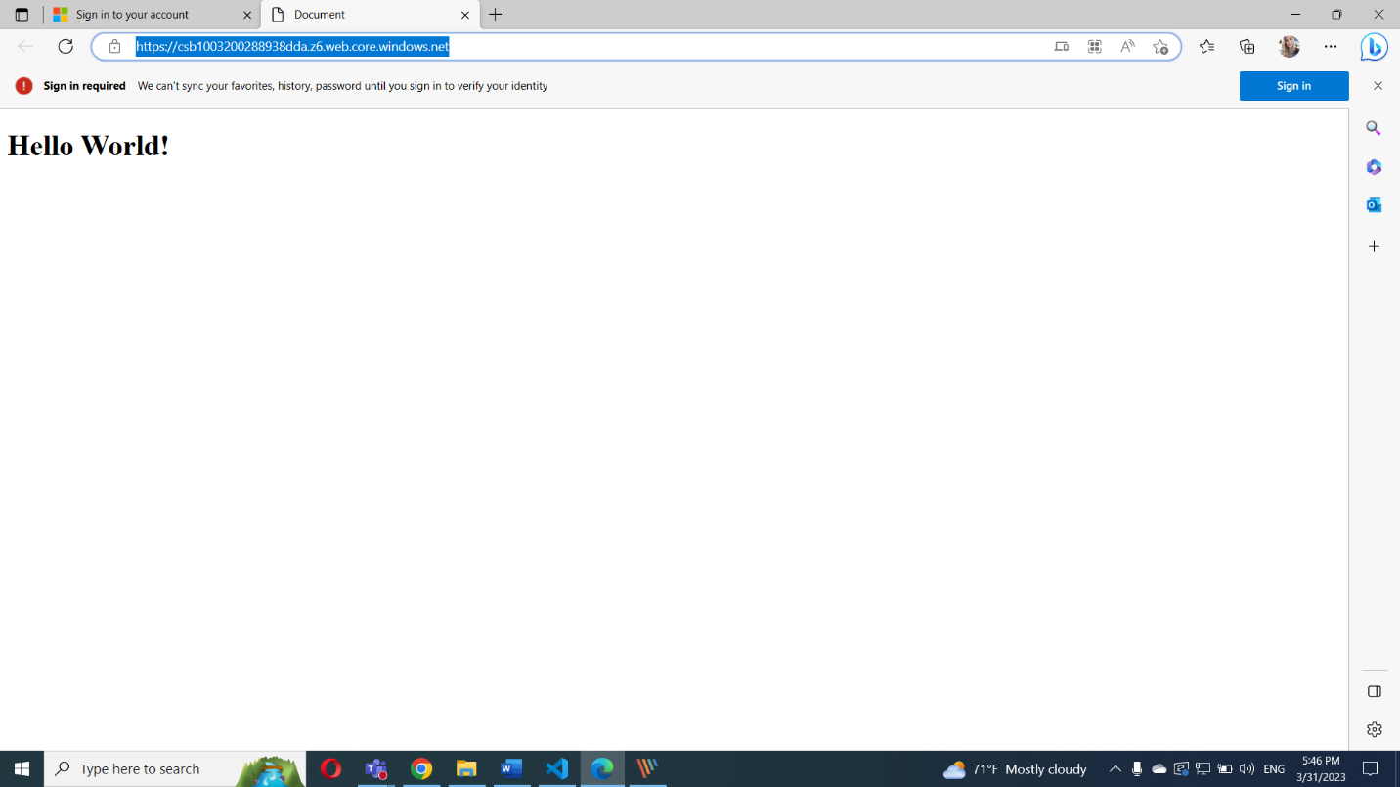

Part II

In this exercise we will setup a Linux based web server and will deploy a web page on it.

1. Create a Virtual Network where you will deploy your Linux Based Web Server.

2. Modify the network security group for your virtual machine that will allow you to remotely manage your machine only from your local machine and nowhere else.

3. Create a Linux Virtual Machine that will be your Web Server which is publicly available for web publishing (not SSL) only from your machine and nowhere else.

4. Connect to the VM.

5. Install Apache Web Server.

6. Deploy the “Hello World” web page.

7. Provide Testing from your cellphone. 8. Provide the steps and results.

Creating virtual network

select **Virtual networks and click create**

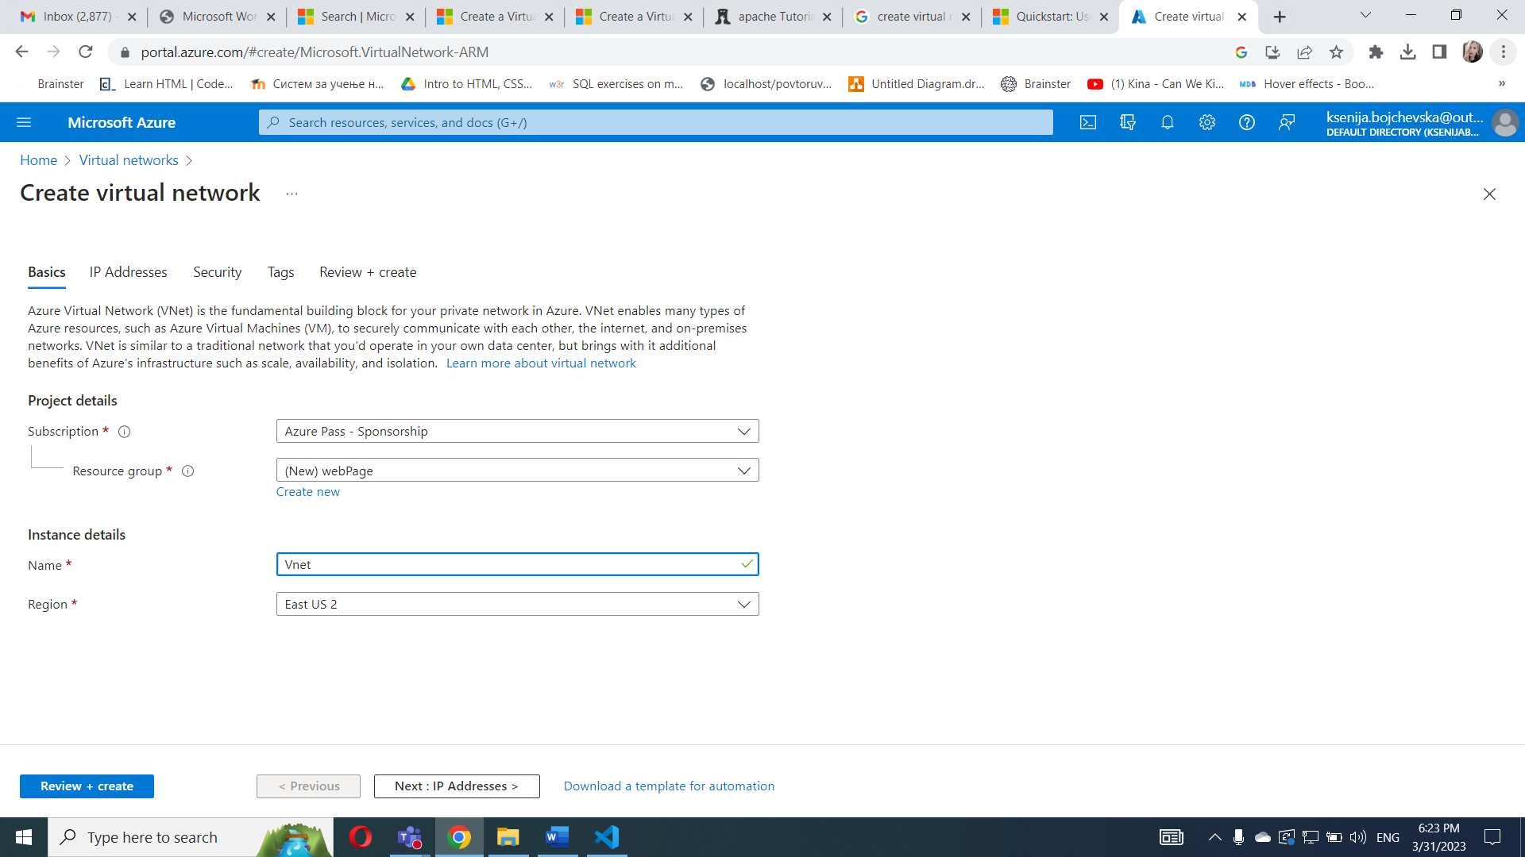

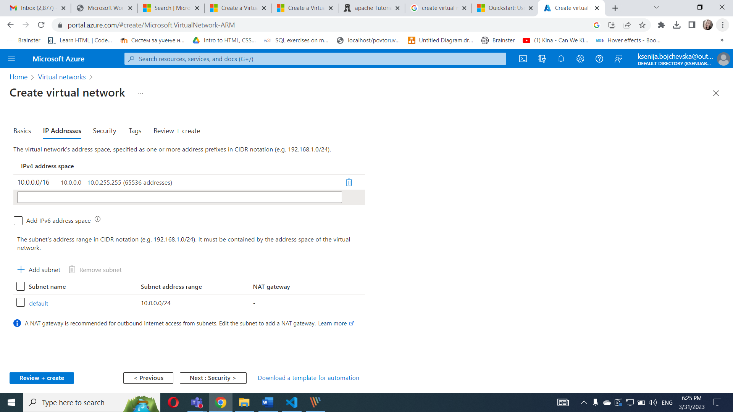

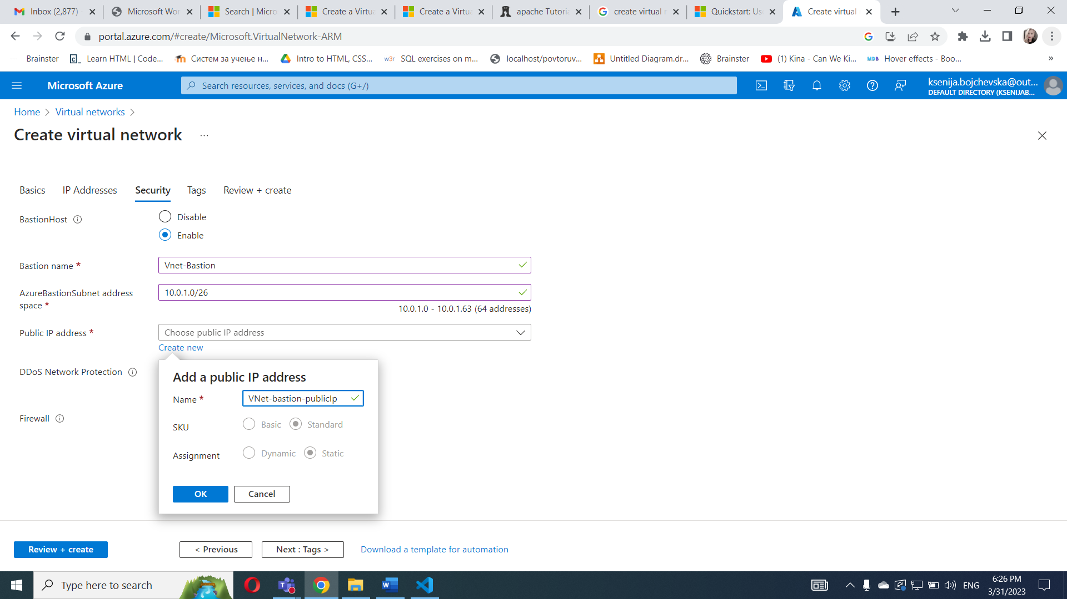

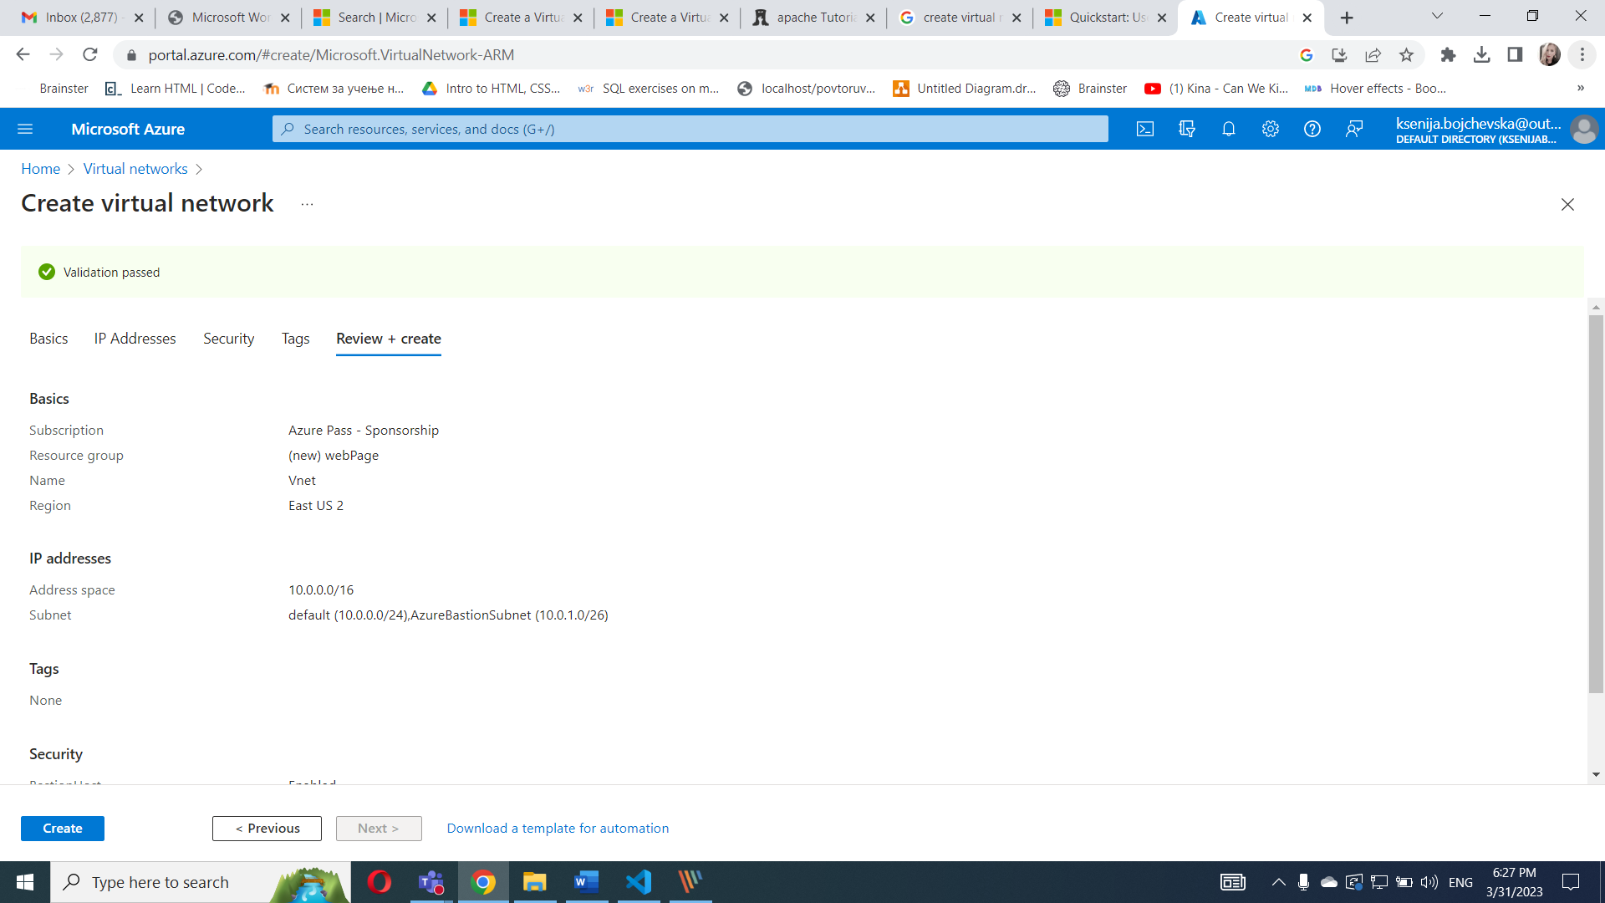

**Create Virtual machine**

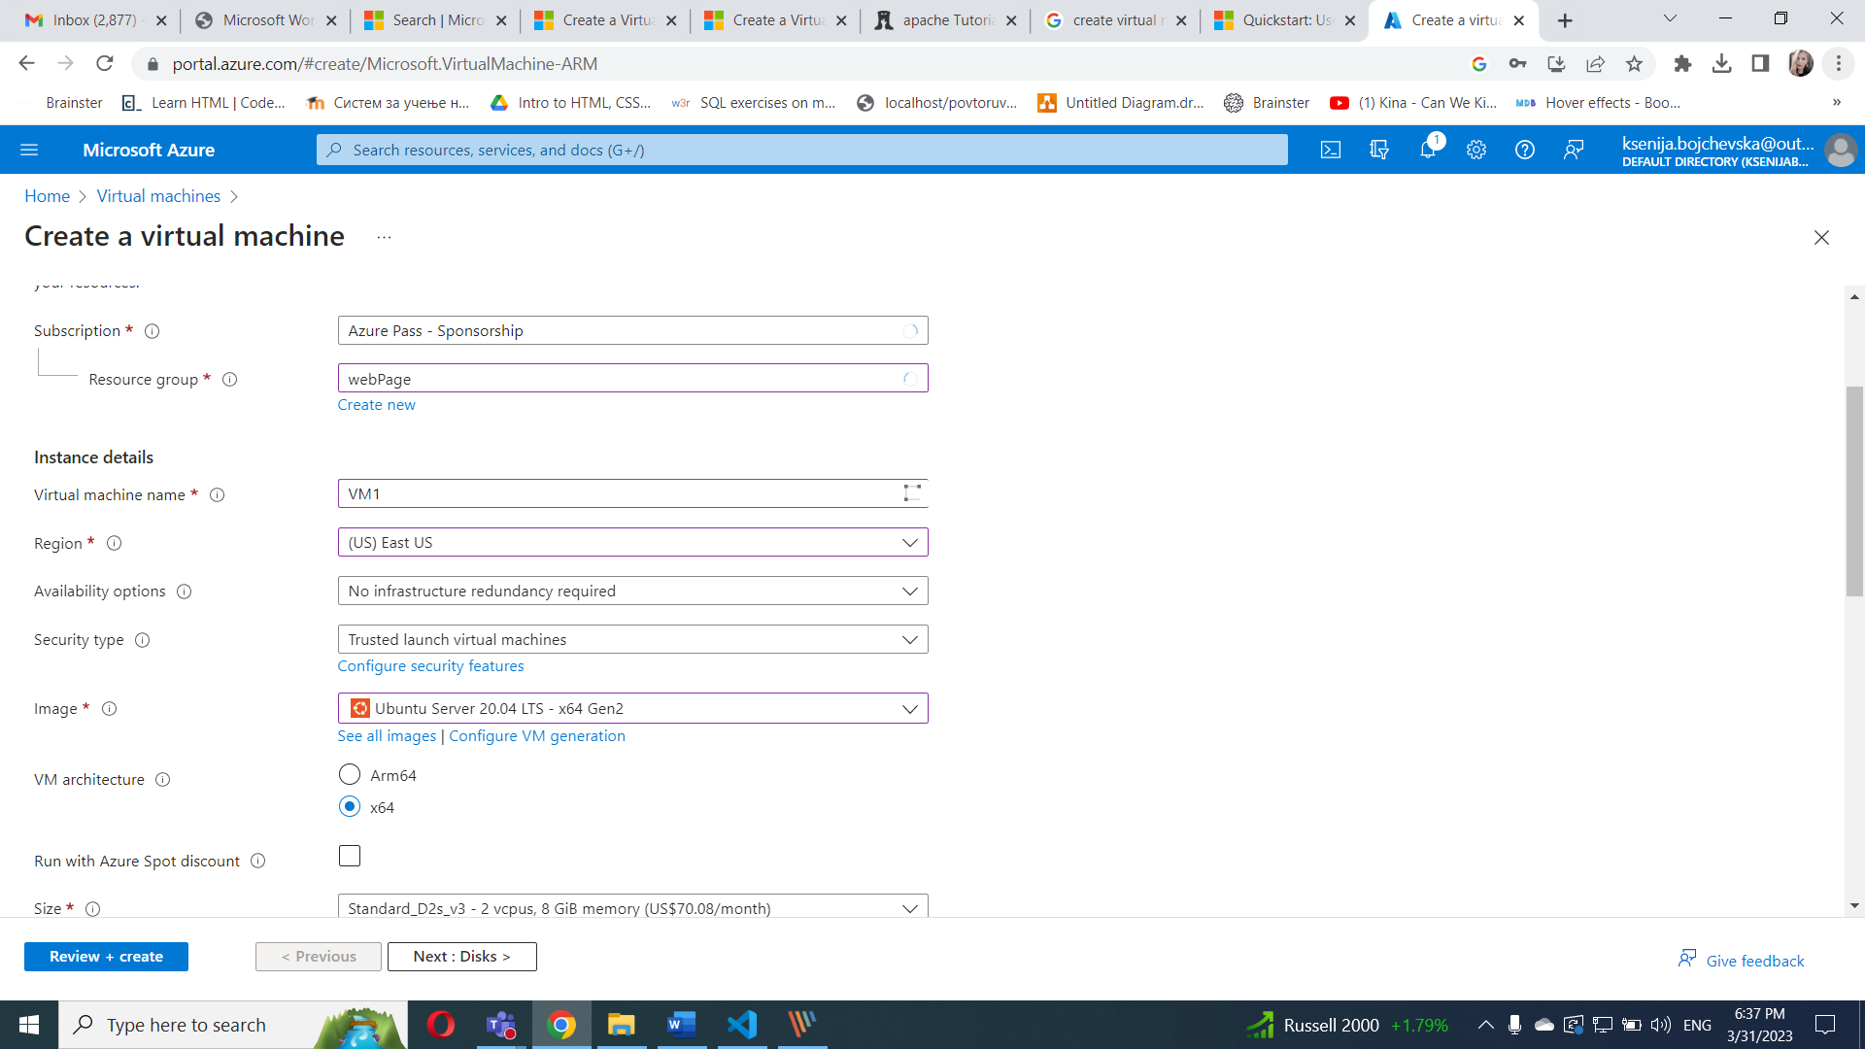

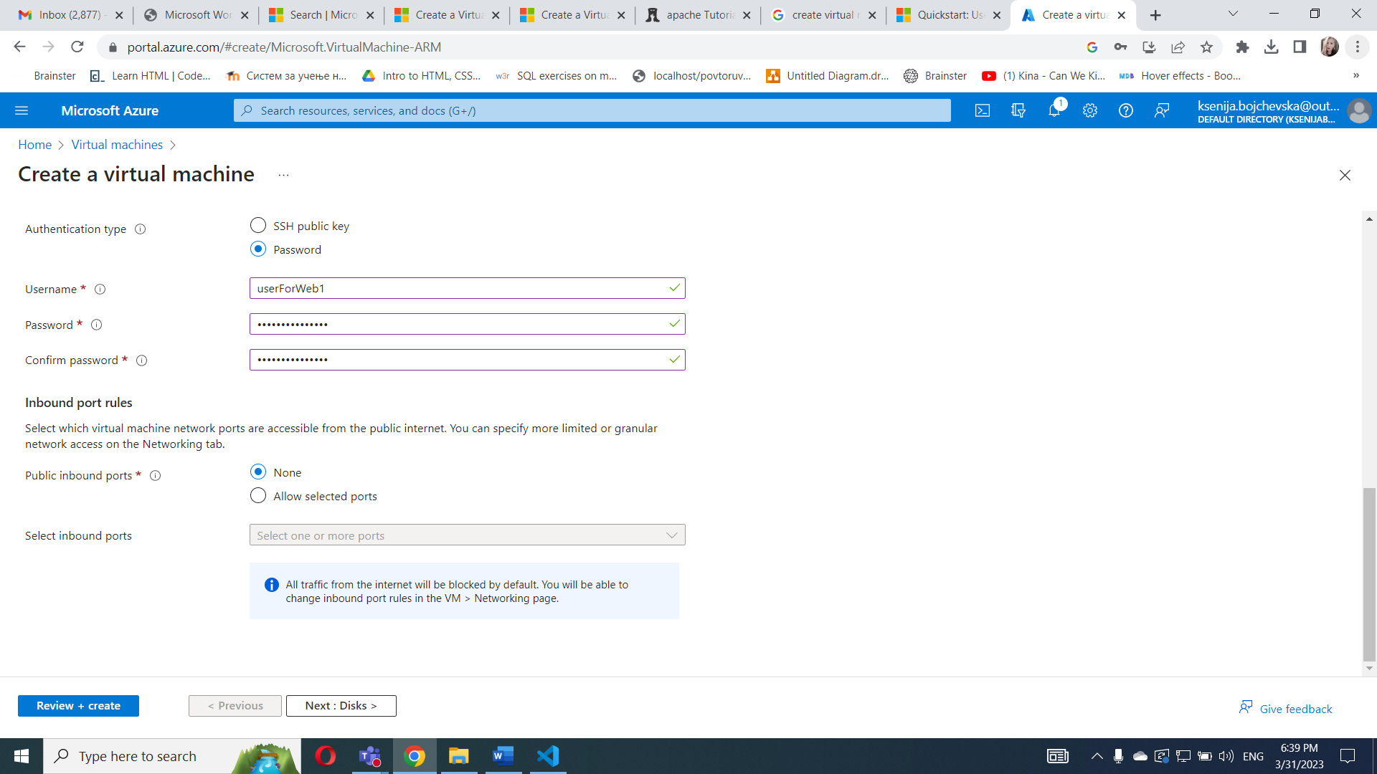

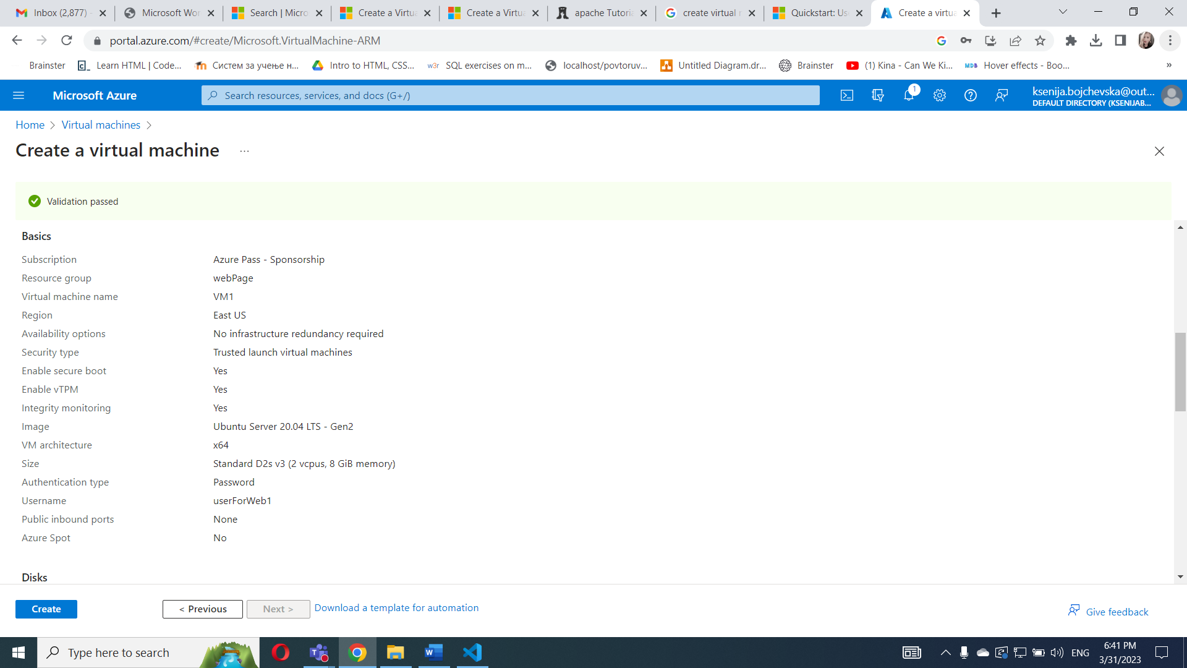

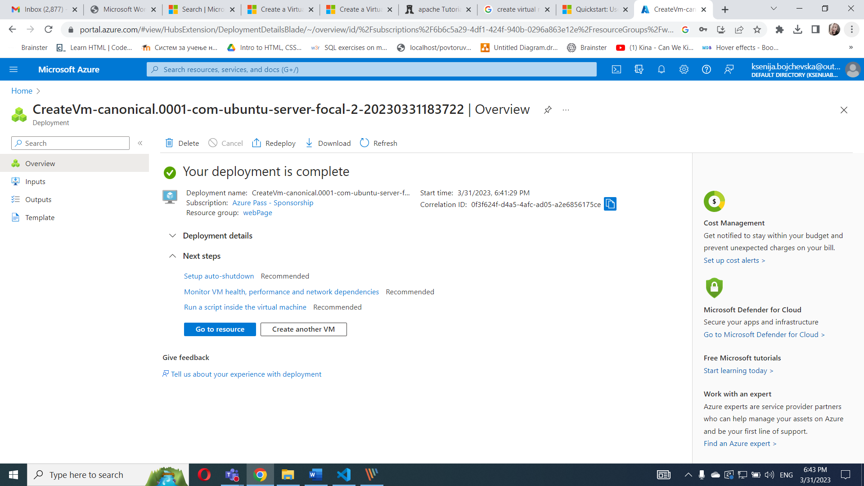

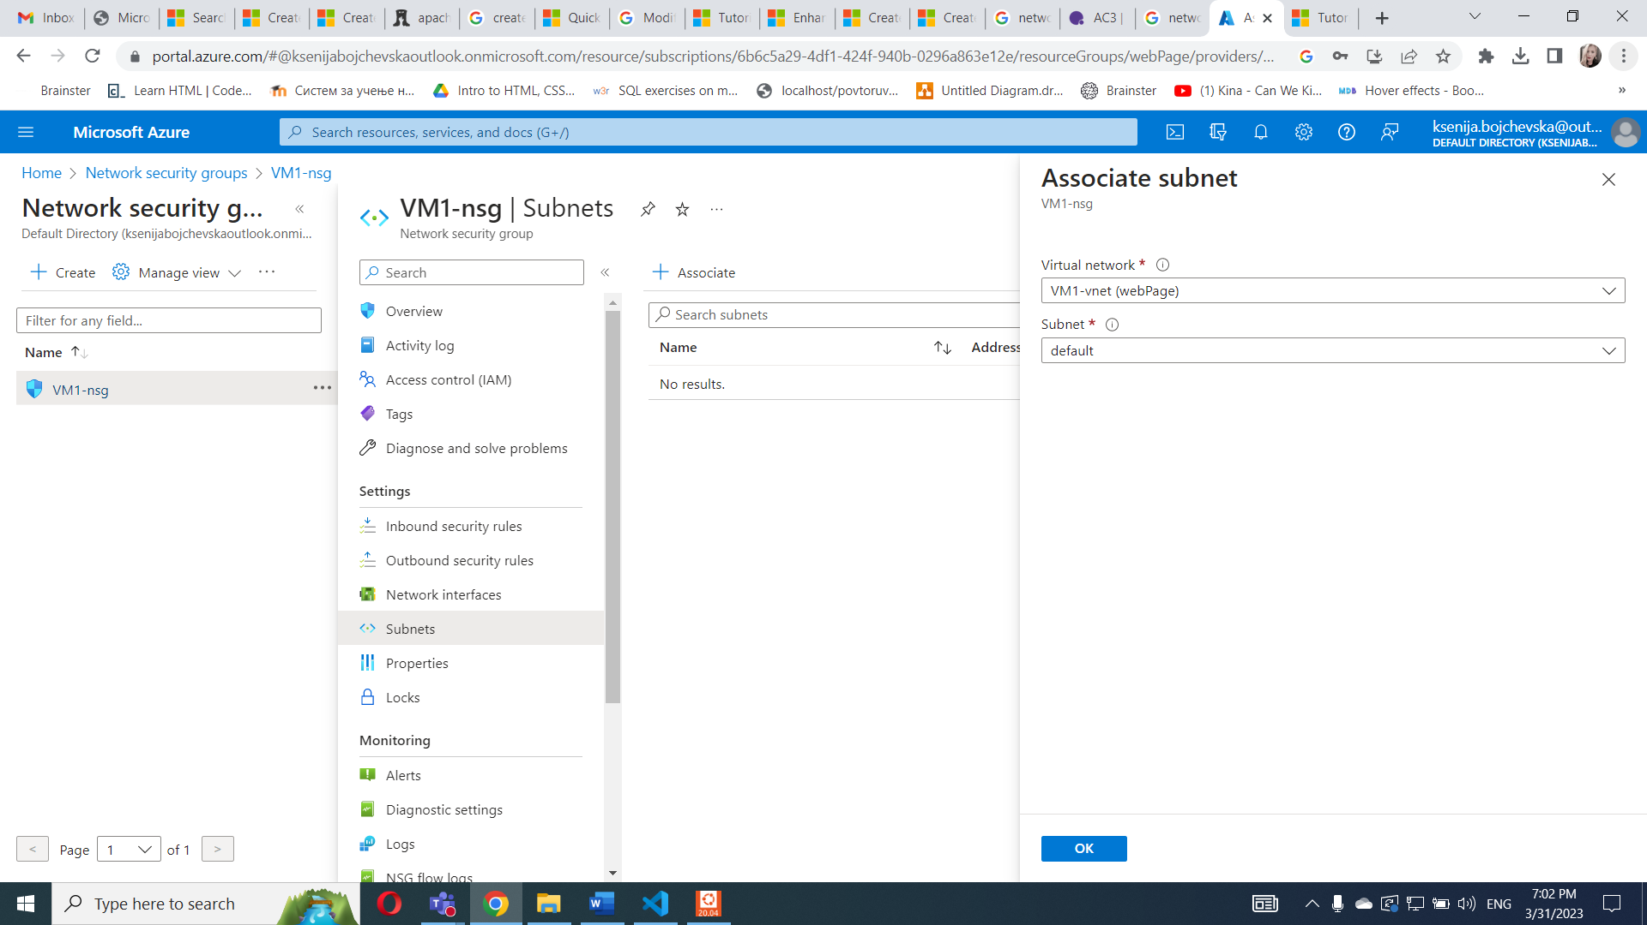

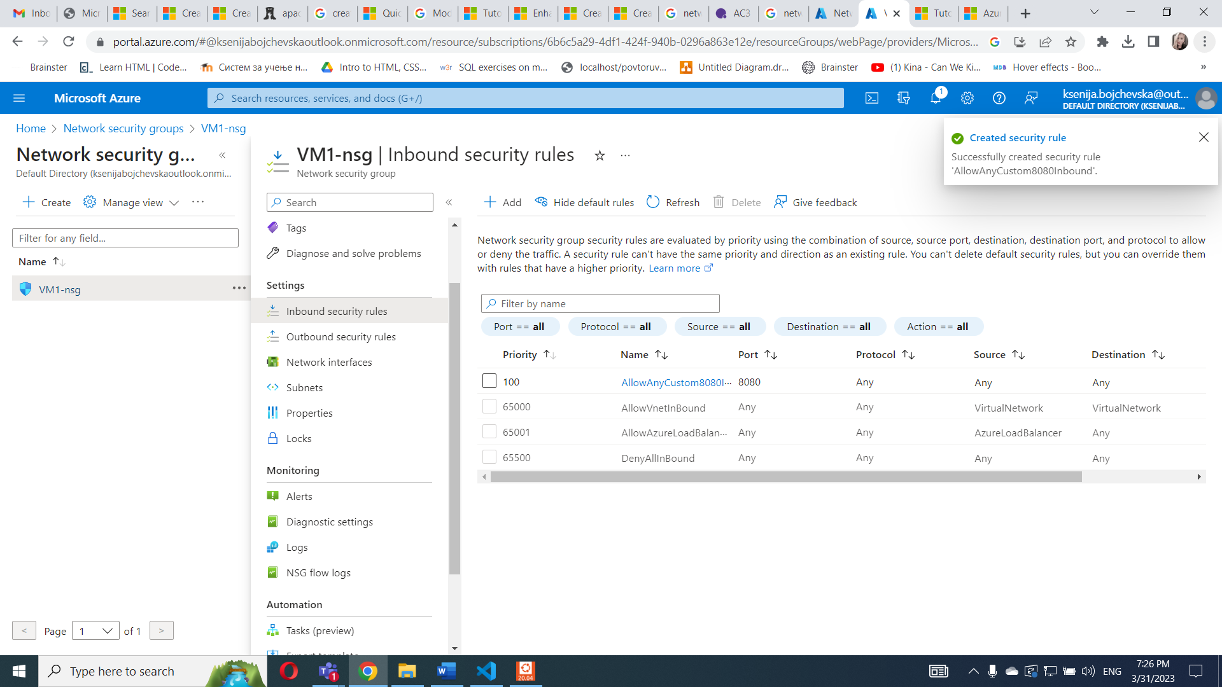

Install Apache Web Server.

